Name :- Singh Chandan Kumar Kunjbihari Div :- A Roll No :- 1

Assignment 3 :- Write a Smart Contract on a Test Network for Bank Account of a Customer for following Operations :-

* Deposit Money
* Withdraw Money
* Show Balance

**Code :-**

pragma solidity >=0.5.1;

//declared the solidity version

//defining a contract contract MyContract {

address private owner;

//define a constructor constructor() public {

owner=msg.sender;

}

//function to get the address of the owner function getOwner()

public view returns (address) { return owner;

}

//function to get return the balancer of the owner function getbalance()

public view returns(uint256){ return owner.balance;

}

//function to deposit money

function deposit() external payable{

require(msg.value == 0.01 ether, "Please send two ethers");

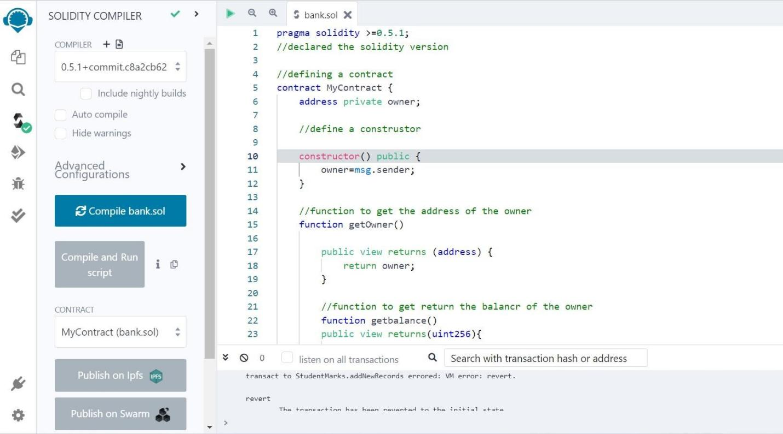

}

//Function to withdraw money function withdraw() external{

require(msg.sender == owner, "No"); msg.sender.transfer(address(this).balance);

}

}

**Output :-**

* Compile and Run :-
* Deploy :-

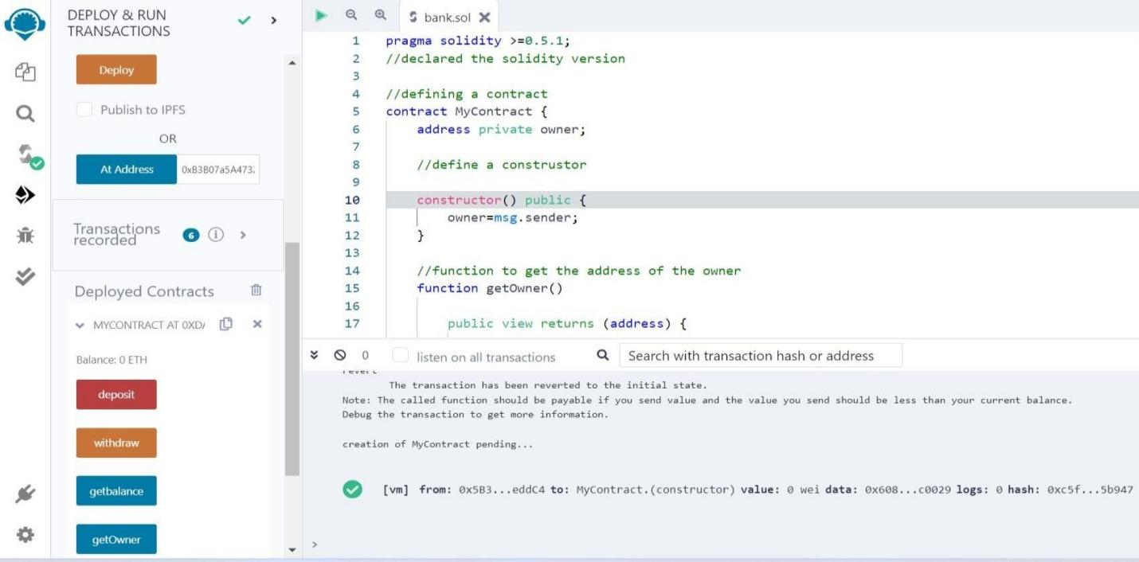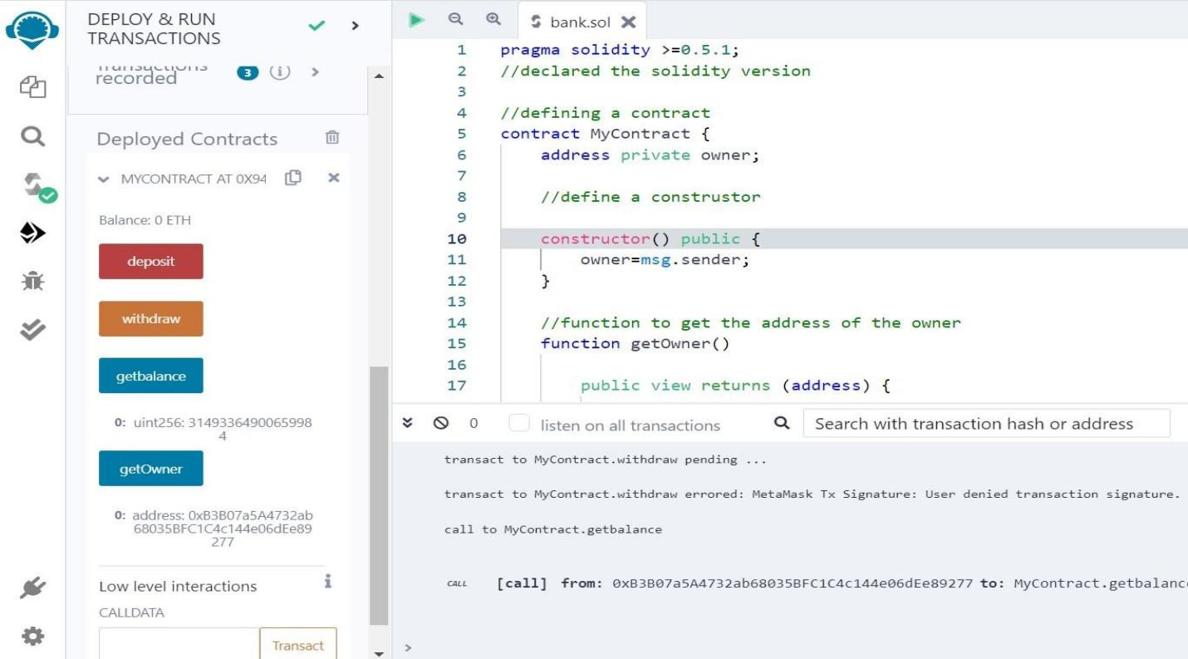

* Transaction Records:-
  + Get Balance:-
* Withdraw the amount :-

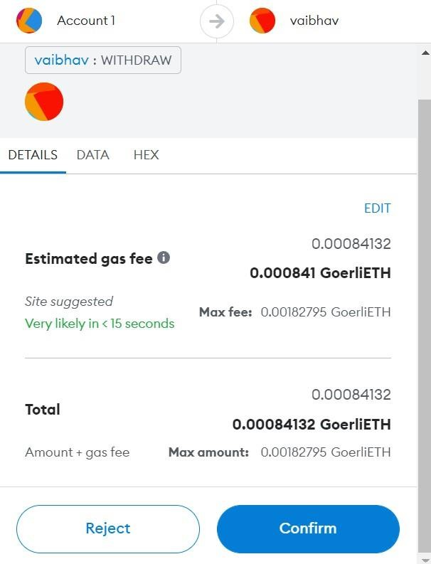

Click on **‘Confirm’**